

DECLARATION

This thesis is submitted in partial fulfilment of the requirements for the Lincoln University  
Degree of Master of Applied Science

The regulations for the degree are set out in the Lincoln University Calendar and are elaborated in a practice manual known as House Rules for the Study of Doctor of Philosophy or Masters Degrees at Lincoln University.

# Supervisor’s Declaration

I confirm that, to the best of my knowledge:

* the research was carried out and the dissertation was prepared under my direct supervision;
* except where otherwise approved by the Academic Administration Committee of Lincoln University, the research was conducted in accordance with the degree regulations and house rules;
* the thesis represents the original research work of the candidate;
* the contribution made to the research by me, by other members of the supervisory team, by other members of staff of the University and by others was consistent with normal supervisory practice.
* external contributions to the research (as defined in the House Rules) are acknowledged.

Supervisor 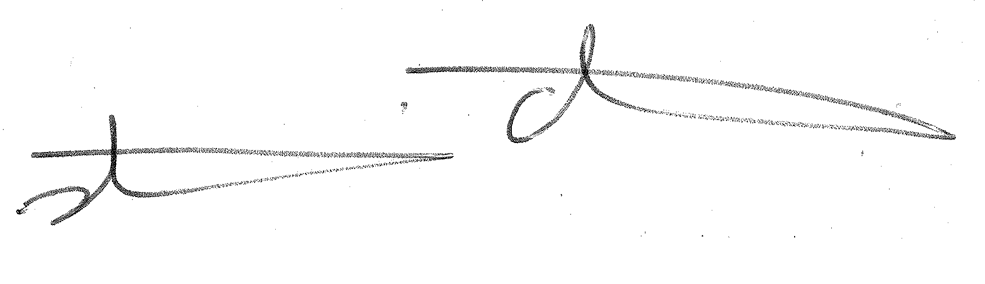 Date 12/10/2023

# Candidate’s Declaration

I confirm that:

* this thesis represents my own work;
* the contribution of any supervisors and others to the research and to the thesis was consistent with normal supervisory practice.
* external contributions to the research (as defined in the House Rules) are acknowledged.   
  Candidate A signature on a white background

  Description automatically generated Date 27/09/2023

# Pre-Publication of Parts of this thesis

1 We confirm that no part of this dissertation has been submitted for publication in advance of submission of the thesis for examination.

Date 27/09/2023

Supervisor Date